

TRIBHUWAN UNIVERSITY

Faculty of Humanities and Social Science

A Project Proposal

On

Online Job Portal

**Submitted To**

Department of Computer Application

Shahid Smarak College

*In partial fulfillment of the requirement for Bachelor in Computer Application (BCA) 8th semester.*

**Submitted by**

Atit Dangaura Tharu

T.U Reg: 6-2-262-2-2019

2024

**Under the supervision**

Hari Lal Chalise

**Table of Contents**

Chapter 1. INTRODUCTION 1

1.1 Introduction: 1

1.2 Problem Statement: 1

1.3 Objectives: 1

Chapter 2: LITERATURE REVIEW 2

Chapter 3: Methodology 3

3.1 Methodology: 3

3.2 Requirement Analysis: 3

3.2.1 Functional Requirements 3

3.2.2 Non-Functional Requirements 4

3.2.3 Stakeholder Requirements 5

3.3 Feasibility Study 6

3.3.1 Technical: 6

3.3.2 Operational: 6

3.3.3 Economic: 6

3.4 Tools: 6

3.5 High Level Design of System: 7

3.6 Gantt Chart 12

Chapter 4: Expected Outcome 13

References 14

LIST OF FIGURES

**Figure 3.1 Waterfall Model** 3

**Figure 3.2 Use Case Diagram** [5] 7

**Figure 3.3 DFD level 0** [6] 8

**Figure 3.4 DFD Level 1** 9

**Figure 3.5 Data Flow Chart** 10

**Figure 3.6 Gantt chart** 12

**LIST OF TABLES**

**Table 3.1 TimeLine** 12

**ABBREVIATION LIST**

AI : Artificial Intelligence

# Chapter 1. INTRODUCTION

## introduction:

The Internet has made this world smaller now. The world environment has been competitive, so an online job portal will be a good platform that connects job seekers with potential employer, allowing them to search for and apply to job opening. In this case, every person wants to reach their heights with their skills and knowledge. These qualities of people inside themselves have reached to the need for a job from remote. To work online and offline, firstly we need to find a work platform. That is, we will actually have to search on the internet for job portals that help us find workplaces such as software developers, civil engineers, mechanical engineers, artists, content writers, etc. All those job postings and searches by the job seeker can be rapidly sent to the intended seeker through the job portal.

## Problem Statement:

A job portal on the earlier time would be challenging to the employees and employers those are given below:

* Users may struggle to find relevant jobs or candidates due to inadequate search and filter options
* The portal might not work well on mobile devices, leading to a poor experience for users accessing it via smartphones or tablets.
* Users might find it difficult to locate jobs or candidates that match their preferences.
* A non-intuitive or slow user interface can frustrate users, leading to a decline in user engagement.

## objectives:

The main objectives of the proposed project are as follows:

* To provide a platform to the job seekers which will help them to get job as per their skills and requirements that would be a better way to the recruiters to hire employees.
* To identify the needs of the recruiter and job seekers with the help of numerous filters and manage their profile as well as keep a track of all the job who are applying to their companies.

# Chapter 2: LITERATURE REVIEW

The paper provides a comprehensive investigation into the evolution and impact of online job portals on the employment landscape. The project is used agile methodology which is best for developing iterative and flexibility in responding to change. The paper discusses the historical development of online job portals, highlighting how they have transformed traditional recruitment methods. This evolution is crucial for understanding the current state of job searching and hiring processes in the digital age [1].

The paper project is a student initiative aimed at creating a comprehensive online platform for job seekers and employers. The primary goal of the Job Portal is to streamline the job search process for individuals. It allows users to search for job openings, apply directly, and manage their resumes and cover letters efficiently. The project utilizes modern technologies and frameworks such as React, NodeJS, Express, and MongoDB. This choice of technology stack indicates a focus on creating a responsive and scalable web application that can handle multiple users and job listings efficiently [2].

The paper discusses the significance and functionality of online portal in the current job market. The paper defines a job portal as a dedicated website that facilitates the connection between job seekers and recruiters. It serves as a platform where both parties can find suitable matches based on specific criteria such as qualifications and preferences. The paper hints at the potential integration of artificial intelligence (AI) and machine learning technologies. These advancements could improve the matching process between job seekers and recruiters by analyzing large datasets to provide more accurate candidate recommendations, thereby streamlining the hiring process for employers [3].

The paper presents a comprehensive overview of an online recruitment system designed to facilitate job searches and postings. The primary aim of the job portal is to manage job information effectively. It allows users to search for jobs, post job listings, and register with employers. This system is designed to streamline the job search process for users and reduce the complexities involved in job applications, such as negotiations and interviews. The project is built using the Django web framework, which is known for its robustness and efficiency in developing web applications [4].

# Chapter 3: Methodology

## 3.1 Methodology:

The waterfall model can make project management easier to this project. It provides clear phases for software development, with each phase building upon the previous one. This structure might be easier to plan and manage the project, as you have clear roadmap to fellow.

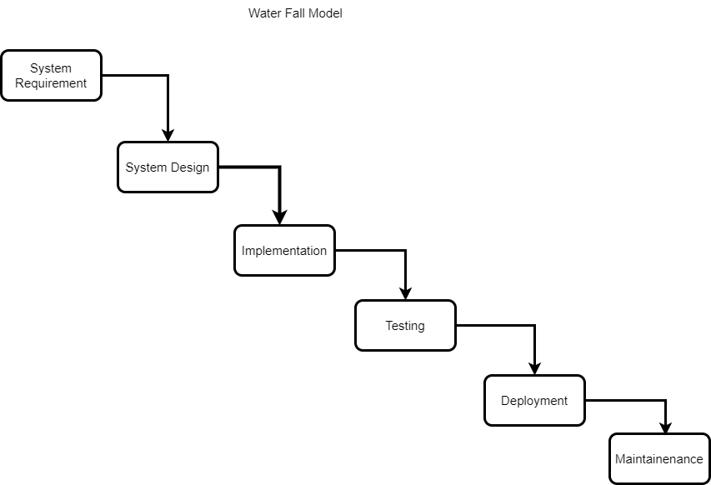

**Figure 3.1 Waterfall Model**

## 3.2 Requirement Analysis:

Identifying requirements for a job portal involves gathering and documenting the functional and non-functional needs of the system. These requirements are essential for ensuring that the job portal meets the expectations of all stakeholders, including job seekers, employers, and administrators. Here’s a breakdown of the key requirements:

### 3.2.1 Functional Requirements

These define what the system should do.

**a. User Registration and Authentication**

* Users (job seekers and employers) should be able to register and log in to the portal.
* Support authentication methods (e.g., email/password).

**b. Profile Management**

* Job Seekers: Ability to create, update, and manage profiles including resumes, cover letters, and personal details.
* Employers: Ability to create company profiles, including company information, logos, and contact details.

**c. Job Posting and Management**

* Employers should be able to post job vacancies with details like job title, description, requirements, location, and salary.
* Ability to edit, update, or delete job postings.
* Option to set application deadlines.

**d. Job Search and Filtering**

* Job seekers should be able to search for jobs using various filters like keywords, location.

**e. Application Process**

* Job seekers should be able to apply for jobs directly through the portal.
* Employers should be able to receive and manage applications, view candidate profiles, and download resumes.

**f. Dashboard**

* Job Seekers: Dashboard showing applied jobs, saved jobs, and job recommendations.
* Employers: Dashboard to manage job postings, view analytics on job views, applications, and candidate demographics.

### 3.2.2 Non-Functional Requirements

These define the system’s behavior and attributes.

**a. Scalability**

The system should be able to handle increasing numbers of users, job postings, and applications without performance degradation.

**b. Security**

* Ensure secure data transmission and storage, especially for sensitive user information.
* Regular security audits and compliance with relevant data protection regulations (e.g., GDPR).

**c. Performance**

* Fast load times and responsive interface, with minimal downtime.
* Efficient search algorithms to handle large volumes of job postings and user queries.

**d. Usability**

* Intuitive and user-friendly interface, with clear navigation and easy-to-use features.
* Accessibility features to support users with disabilities.

**e. Compatibility**

* Cross-browser compatibility and optimization for different screen sizes, especially mobile devices.

**f. Reliability**

* High availability with backup and recovery options in case of system failure.
* Regular updates and maintenance to ensure the system remains reliable.

**g. Maintainability**

* The system should be easy to maintain, with clear documentation and modular architecture to support updates and feature enhancements.

**h. Data Integrity and Consistency**

* Ensure data consistency across the system, especially when users update profiles, job postings, or application statuses.

### 3.2.3 Stakeholder Requirements

These capture the needs and expectations of different stakeholders.

**a. Job Seekers**

* Easy profile setup and job search.
* Personalized job recommendations.
* Clear communication

**b. Employers**

* Efficient job posting and candidate management.

## Feasibility Study

### 3.3.1 Technical:

Assess the availability of required hardware, software, and technical expertise to develop and deploy the system.

### Operational:

Evaluate the system's compatibility with existing job portal workflows, user acceptance, and the resources required for training and implementation.

### Economic:

Analyze the costs and benefits of implementing the system, including development, Maintenance, and potential savings through distributed job post to the seekers.

## 3.4 Tools:

* Front End
* React
* Redux
* Back End
* Node JS
* Express
* Mango DB

## 3.5 High Level Design of System:

1. **Use Case Diagram:**

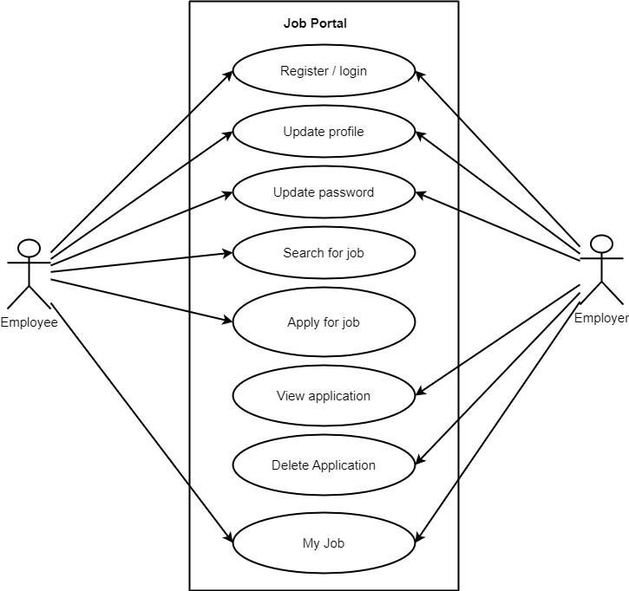

**Figure 3.2 Use Case Diagram** [5]

1. **Data Flow Diagram (DFD)**

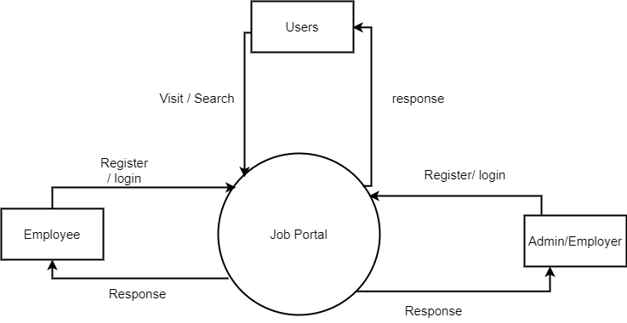

**Figure 3.3 DFD level 0** [6]

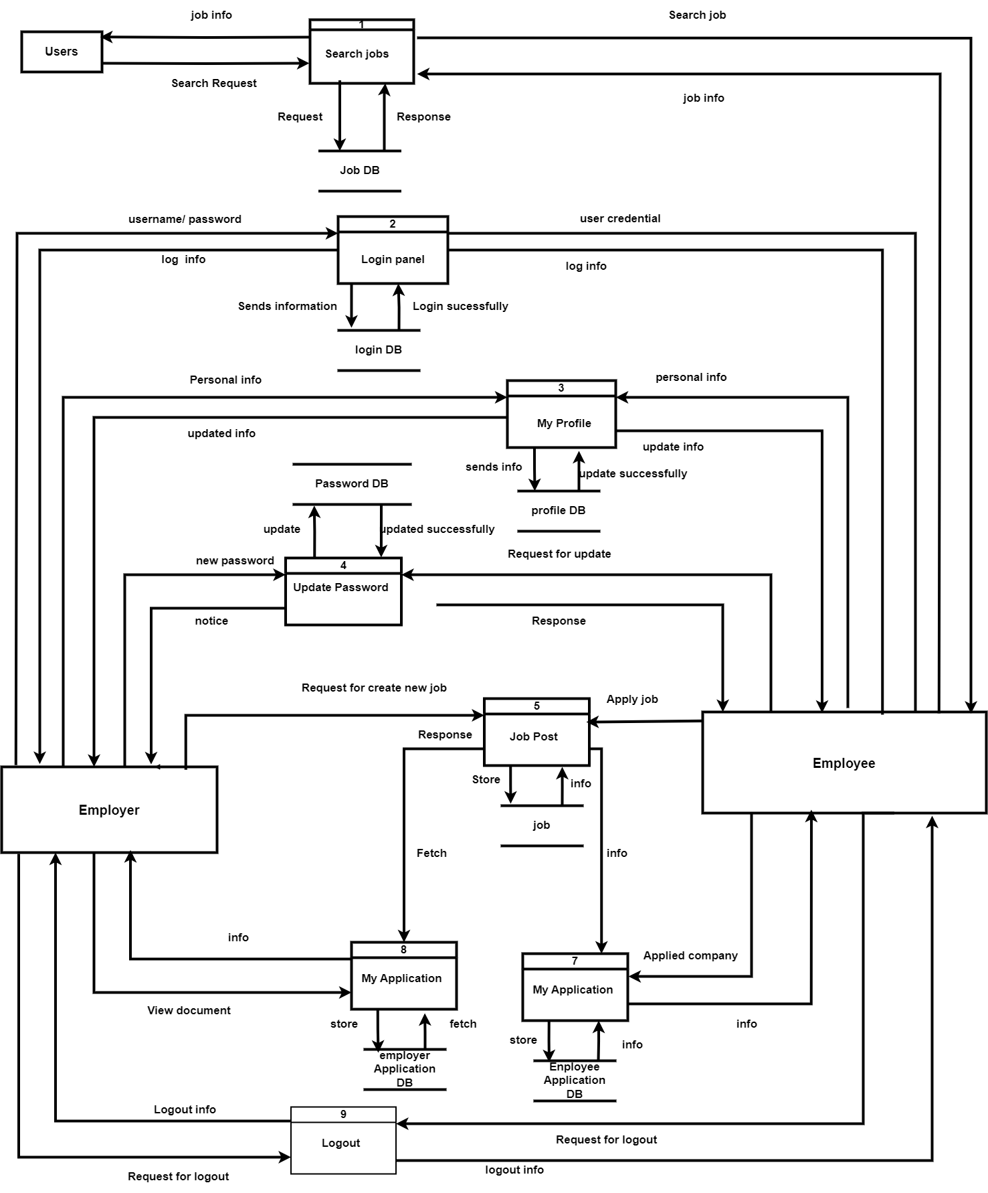

**Figure 3.4 DFD Level 1**

**D) Flow Chart**

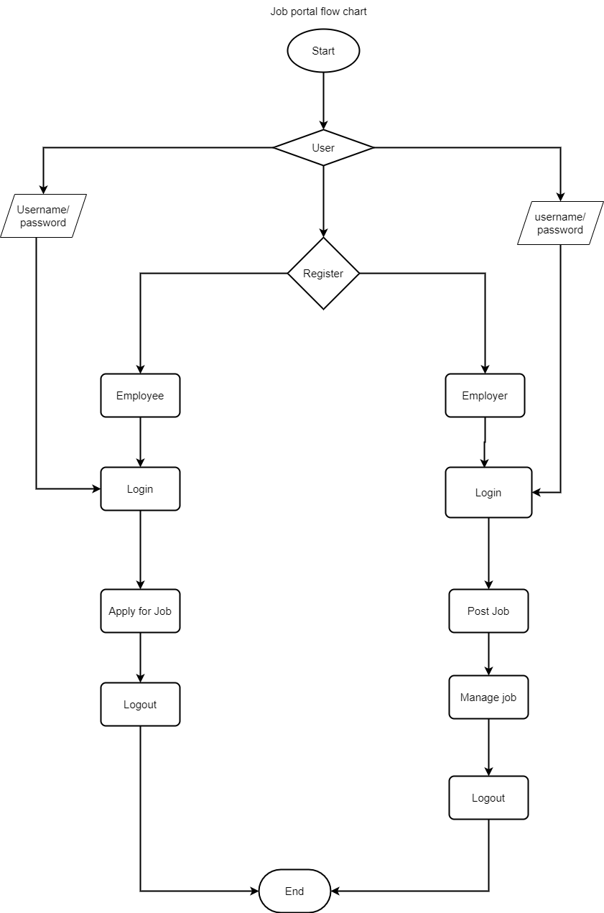

**Figure 3.5 Data Flow Chart**

**F) Description of Algorithms:**

* **Search Algorithm:**

Searching is the process of fetching a specific element in a collection of elements. The collection can be an array or a linked list. Actually it uses text-based search to match job descriptions with user entered keywords which linear search. Here say that the procedures of implementing search algorithms. First, read the search element in the array. In the second step compare the search element with first element in the array. If both are matched, display “target element if found” and terminate the search function. If both are not matched, compare the search element with the next element in the array. In this step, repeat Step 3 and 4 until the search element is compared with the last element of the array. If the last element in the list does not match, the linear search function will be terminated, and the message “element is not found” will be display.

* **Recommendation Algorithm:**

A recommendation algorithm is a combination of a datasets and machine learning that provides personalized recommendation based on users’ historical data. The recommended algorithm is used in recommender systems as is a type of data filtering that helps to predict user preference and interests, making it easier to find content or products they might like or be interested in. Rather than showing content you’ve chosen to see such as the pictures and posts of people you follow, these kinds of algorithms show content they think you’ll be interested in based on previews interactions.

## 3.6 Gantt Chart

The project schedule will outline the tasks, milestones, and timelines for each development phase, including analysis, design, implementation, testing, and deployment. It will also allocate resources and assign responsibilities to ensure timely completion.

**Table 3.1 TimeLine**

|  |  |  |  |
| --- | --- | --- | --- |
|  | Start Date | End Date | Duration |
| Planning | 6/5/2024 | 6/7/2024 | 2 |
| Analysis | 6/8/2024 | 6/13/2024 | 5 |
| Design | 6/14/2024 | 6/30/2024 | 16 |
| Coding | 7/1/2024 | 8/20/2024 | 50 |
| Testing | 8/21/2024 | 8/24/2024 | 3 |
| Delivery | 8/25/2024 | 8/27/2024 | 2 |

**Figure 3.6 Gantt chart**

# Chapter 4: Expected Outcome

After completion of my project, expected outcomes include:

* Employee and employer create a smooth platform where job seeker can easily find and apply for relevant job opportunities.
* While employers can efficiently post job openings, manage applications, and identify qualified candidates.
* Additionally, employers can offering features such as personalized job recommendations, robust search and filtering options, secure communication tools.
* This platform aims to simplify the hiring process, reduce time-to- hire, and enhance the overall experience for both parties by making job matching more accurate and efficient.

# References

|  |  |
| --- | --- |
| [1] | N. Sonawaner, "Online Job Portal," *Indian Scientific Journal Of Research In Engineering And Management ,* pp. 3,838, 2024. |
| [2] | D. T. M. Adithyan s, "Job Portal," *International journal of advanced research,* pp. 2,118, 2023. |
| [3] | G. R. R. G Ramarao, "Job Portal," *International Journal of Advanced Research in Science, Communication and Technology ,* pp. 1,720, 2024. |
| [4] | Mangesh Kumar Yadav, "Online Job Portal using Django," *International journal of innovative science and modern engineering,* p. 11, 2024. |
| [5] | M. M. KISOI, "JOB PORTAL," BarristerStarZebra7, 2022. |
| [6] | admin, "A Project Report On Online Job Portal," 1000 projects, 2017. |